**Debunking Prairie Dog Myths**

**Q: Do prairie dogs spread disease?**

**A: *No.***

They are the victims of disease, specifically plague. Settlers brought plague to North America. Plague is carried into prairie dog towns by fleas on other animals. If you see prairie dogs alive and well, plague is not present. Nobody who works with prairie dogs has ever contracted plague. Eliminating prairie dogs does not reduce the incidence of plague.

**Q: Are prairie dogs destructive to rangeland vegetation?**

Name _______________________

Address _______________________

_______________________

Phone _______________________

Email _______________________

* I am interested in volunteering.

*Please contact me to discuss ways I can get involved!*

**A: *No.***

Scientists have discovered they improve natural grassland conditions. They are not at fault for denuded sites in urban areas where they are surrounded by development. Prairie dogs have also been proven to be the effect, as opposed to the cause, of overgrazing. In areas where prairie dogs have been eliminated, the land rapidly converts to desert conditions.

**Q: Do prairie dogs reproduce and expand rapidly?**

**A: *No.***

Prairie dogs are annual breeders. Half of the females over 2 years old will give birth to about 4 pups. Prairie dogs do not continually expand, but experience natural population cycles when left alone.

**What Can You Do To Help Prairie Dogs?**

Join Prairie Dog Pals! Prairie Dog Pals volunteers help with stewardship, rescue and education!

Use your skills to help with:

* Administrative Tasks
* Caregiving
* Fundraising
* Graphic Design
* Public Relations



* Public Speaking
* Relocations
* Web Design
* And More!

Clip and mail form to:

Prairie Dog Pals

Address: PO Box 14235

Albuquerque NM 87191

Phone: 505 296 1937

Email: prairiedogpals@comcast.net

Website: www.prairiedogpals.org



Stewardship.

Rescue.

Education.

Prairie Dog Pals is dedicated

to the welfare, preservation and continuous humane care of urban prairie dogs within New Mexico,

as well as the education of the

public about the species.

Prairie Dog Pals

PO Box 14235

Albuquerque NM 87191

505-296-1937

[prairiedogpals@comcast.net](mailto:prairiedogpals@comcast.net)

www.prairiedogpals.org

**Prairie Dog Pals’ Goals**

* Preserve appropriate areas of land where prairie dogs naturally exist in the Greater Albuquerque area.

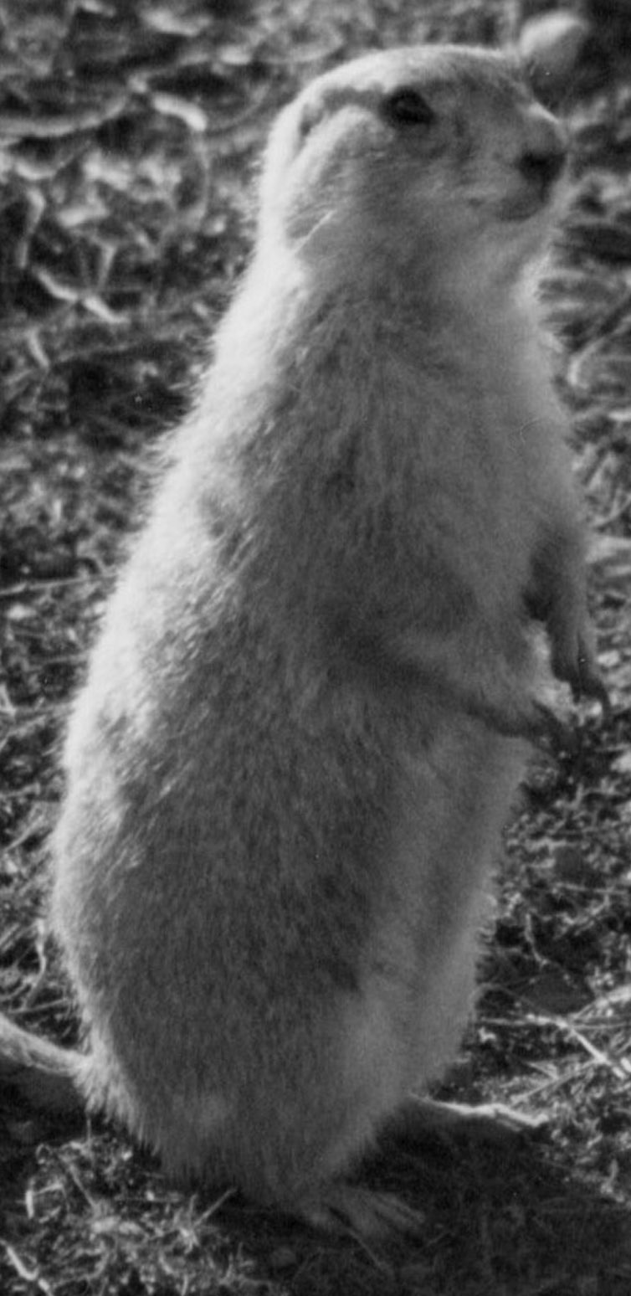

* Preserve areas of historical habitat for prairie dogs in all New Mexico counties.
* Allow prairie dogs and other native wildlife to co-exist with humans and domestic animals in historical habitats.

**Prairie Dogs ~ Heritage of the West**

There are five species of prairie dogs that inhabit North America. Overall, they now inhabit about 1% – 2% of their former range. Utah and Mexican Prairie Dogs are protected under the Endangered Species Act. Black-tailed Prairie Dogs are a candidate “Threatened Species”. White-tailed and Gunnison’s Prairie Dogs are being considered for legal protection by the U. S. Fish & Wildlife Service. Gunnison’s exclusively inhabit the ‘four corners’ region of AZ, CO, NM, and UT. Southwestern grasslands were once abundant with Gunnison’s Prairie Dogs. Through rampant poisoning, shooting, overgrazing of livestock, and urban development, their populations have been reduced by about 98%.



Burrowing Owls, a protected species, rely on prairie dog burrows for their homes.

**Prairie Dogs ~ Keystone Species**

All species of prairie dogs are the most important element of their environment. Prairie dogs support 150 vertebrates and enrich plant communities in their habitat.

* Prairie dogs are the primary prey for wildlife on rangeland.
* Prairie dog burrows provide homes or shelter for other species.
* Prairie dogs improve vegetation conditions for grazing.

One of the most endangered mammals in the world, the Black-footed Ferret, is completely dependant on prairie dogs as a food source.

Other federally protected species are nearly as dependant including the Swift Fox, the Ferruginous Hawk, the Burrowing Owl, and the Mountain Plover.

Historically, prairie dogs resided in regions grazed by Bison, Pronghorn, elk, and deer.

In natural settings, they have a positive effect on plant communities. Research has concluded that prairie dogs play a crucial role in grassland restoration.

**Social Structure and Language!**

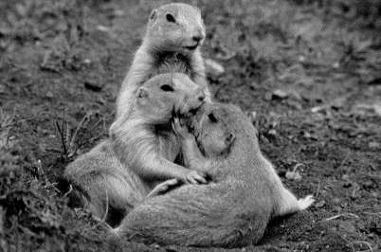

*Prairie dogs are highly evolved and social.*

**Family Life:** Prairie dogs live in evolved family units called “coteries”. Prairie dog towns are comprised of multiple coteries.

**Language Skills:** Conclusive studies on the nature of prairie dog language have revealed that they possess the most complex language of any animal ever studied. They often communicate in sentences and invent descriptions for conditions unique to their colony.

**Cognitive Thought:** Biologists have demonstrated that they have cognitive thought. (Reasoning skills)

**Living Quarters:** Prairie dog burrows are fascinating.

* A home burrow may be over twelve feet deep and have several entrances.
* A “listening post” is often constructed near the entrance.
* A “toilet” is found just beyond the listening post.
* Sleeping chambers and storage rooms are found below.