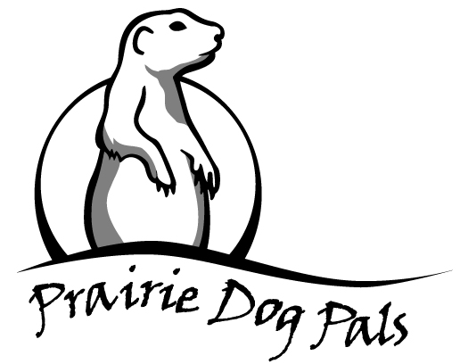

**Volunteer**

**Waiver of Liability**

As a volunteer participating with Prairie Dog Pal’s programs for the care, feeding, site management, capture, relocation, release of prairie dogs and/or outreach activities (PROGRAM), I will conduct myself in a safe and professional manner, adhering to applicable regulations, laws, codes, and standards at all times. I will strive to set a good example by treating the prairie dogs, as well as all animals I encounter in connection with the PROGRAM in a humane manner and encourage others to follow humane practices as well. I will strive to educate the public by providing factual information about prairie dogs.

As consideration for being allowed to participate in the PROGRAM, I agree that I am responsible for my own safety and well being during my participation in the PROGRAM and I do not rely on Prairie Dog Pals to provide for my safety and well being during my participation in the PROGRAM. I UNDERSTAND THAT WORKING OUTDOORS, AND WORKING WITH ANIMALS, CARRIES A RISK OF INJURY, INCLUDING BUT NOT LIMITED TO RISKS ASSOCIATED WITH ANIMAL AND INSECT BITES AND EXPOSURE TO DISEASE, AND THAT IT IS POSSIBLE THAT I MAY BE INJURED DURING MY PARTICIPATION IN THE PROGRAM. I agree to hold Prairie Dog Pals harmless for any injury or medical or other health care problem I may incur during my participation in the PROGRAM, regardless of cause, and agree to pay any medical cost related to any injury or illness that I may incur during my participation in the PROGRAM. I agree that neither Prairie Dog Pals nor its insurers, if any, shall be responsible for payment of expenses relating to any injury I may sustain.

As consideration for being allowed to participate in the PROGRAM, I hereby release Prairie Dog Pals and its directors, officers and agents from all actions, damages, or claims which I or my heirs may have against them arising from my participation in the PROGRAM, including travel to and from any work site associated with the PROGRAM, and from the use of any equipment belonging to or under the control of Prairie Dog Pals or its directors, officers and agents. I also agree to hold Prairie Dog Pals harmless against all actions, damages, or claims which may arise against Prairie Dog Pals, its directors, officers and agents, as the result of my participation in the PROGRAM, including my use or operation of any equipment associated with the PROGRAM.

I further agree that this Waiver of Liability and all hold harmless provisions will apply to the Sevilleta National Wildlife Refuge, City of Albuquerque, or Albuquerque Public Schools and to any private or commercial property owner when I am participating in the PROGRAM on its property, .

I expressly agree that this Waiver of Liability is intended to be as broad and inclusive as permitted by the laws of the State of New Mexico and that this Waiver of Liability shall be governed by and interpreted in accordance with the laws of the State of New Mexico.

I have read, understand, and agree to this Waiver of Liability.

Volunteer’s Printed Full Name

Signature of Volunteer Date

Signature of Witness Date