

Yvonne Boudreaux PO Box 14235
President Albuquerque, NM 87191
(505) 296-1937
www.prairiedogpals.org
prairiedogpals@comcast.net

Pocket Gophers
An overview by Paul Polechla Jr., Ph.D.,

Prairie Dog Pals receives frequent calls about mysterious animals burrowing in people’s yards. Typically, owners are alerted to the presence of these animals by fresh mounds of dirt. There are no apparent burrows and the responsible animal is infrequently seen. Prairie dogs can be dispersed by construction, disturbance, or by territorial issues, but in most cases the burrowing animal is a pocket gopher. To help homeowners cope with these uninvited guests we have requested that Dr. Paul Polechla prepare this overview of pocket gophers, their habits and some suggested interventions.

What are pocket gophers?
Pocket Gophers of New Mexico and much of the west are not to be confused with animals of trans-planted New Mexicans former homes…like gopher tortoises of southeastern U.S., gopher snakes of the Midwest and West, gophers…a term for some species or kinds of ground squirrels (with stripes or spots on back). These pocket gophers are actually rodents distantly related to pocket mice (can fit into your shirt pocket) and kangaroo rats (might fit into overalls pants pocket) but are even more adapted for digging. They do share with the night-active pocket mice and kangaroo rats the fur-lined cheek pouches for temporary transport of their food…like a shopping bag only it is handier. Unlike moles that occur in areas such as eastern U.S. and the Pacific northwest that are more wet or “mesic”, most pocket gophers occur in drier soils of grasslands and deserts. Moles are in an insect-eaters or “insectivores” and have peg-like teeth for breaking up insects, earthworms, and other invertebrates. Pocket gophers eat plant material. There are seven different species of pocket gophers in New Mexico and more than 35 are found in the Americas from Canada to Costa Rica. They’re All American! Only one species occurs east of the Mississippi River. They vary from 5 ½ to 7 ½ inches long and weight from 6 to 8 ounces. They have two pairs of buck or “incisor” teeth to cut roots and shoots and complex cheek teeth or “molars” to grind the plants up. They have paddle shaped front feet for digging through the soil and a small sensitive tail that allows them to back up in their dark burrows.

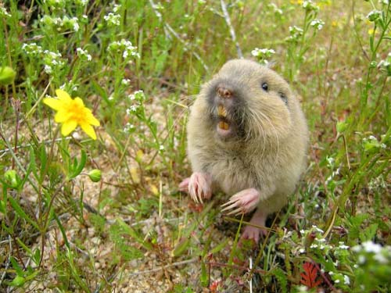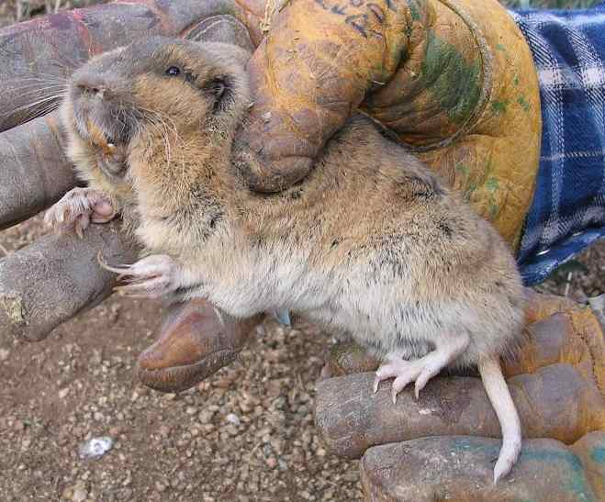

Pictured above are examples of pocket gophers.

What do pocket gophers do?

Pocket gophers dig and often leave mounds of soil heaped over the plug of their exit/entrance hole. Prairie dogs (size of a loaf of bread and weigh about a pound as an adult) do not make mounds but do dig holes that enter to their underground burrow. Sometimes there are volcano-like craters around a prairie dog hole. If you can see an open hole in the ground then it is not a pocket gopher. Pocket gophers hide their hole by plugging them when not in use. Pocket gophers spend about 99% of the time below ground level in search of fleshy plant roots, bulbs, and shoots.
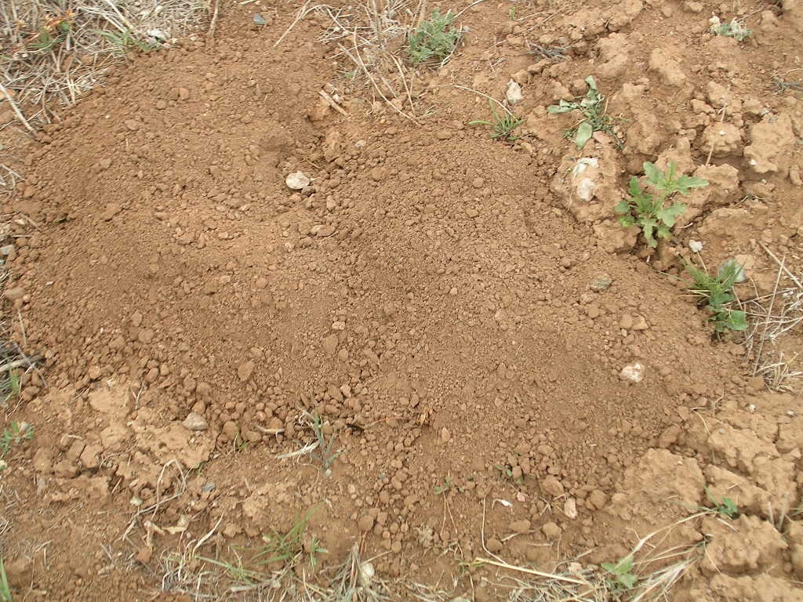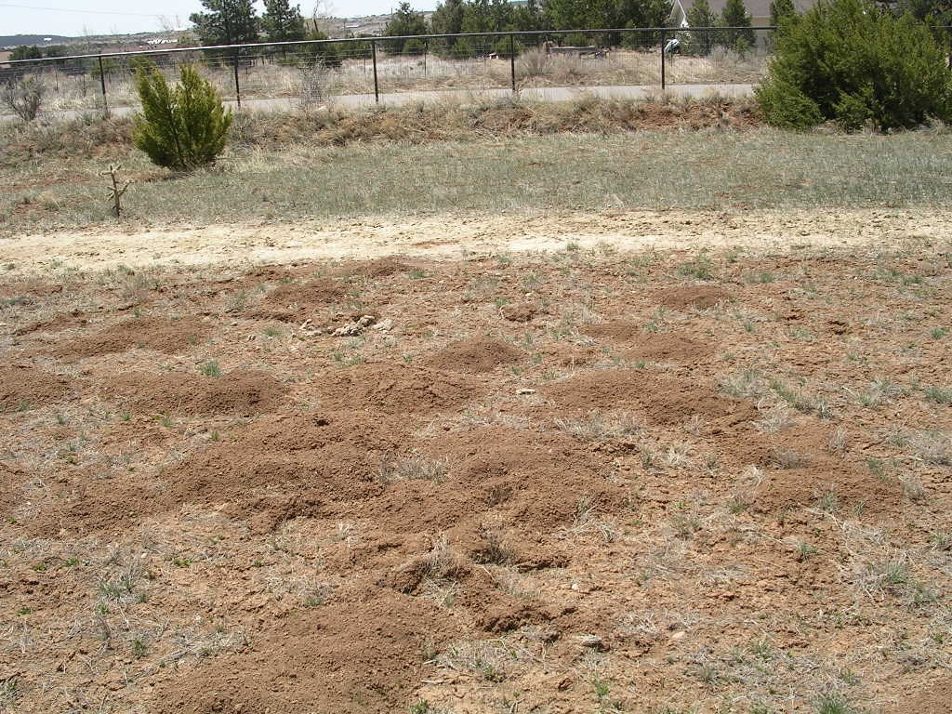

Pictured above are examples of gophers at work.

Should I worry about pocket gophers digging?
If they were in your lawn, I would say no. The plants they target are broad-leaved plants and your grasses are narrow leaved plants with unappealing narrow roots. The fussy lawn keeper regards the broad-leaved plants as weeds. So the pocket gophers are helping the average gardener and lawn keeper weed their property! Cool, huh? And they do it for free!

What else do they do?
These little guys (and gals too) spend their time wandering through their maze of underground tunnels and digging new ones. Their digging action brings deep soil rich in minerals to the surface, thereby mixing it. Their droppings fertilize the soil adding nitrogen and organic matter. Their tunnels allow for the mixing of oxygen and carbon dioxide to allow your plant roots to “breath”. They are doing this 24 hours a day, 7 days a week, and 365 days a year….for free! They are in fact master gardeners!

What if I don’t like those stupid mounds?
Take the backside of a rake and stroke it across the gopher mound until smooth. Repeat when you see other mounds. They only make the mounds when they are digging new tunnels. Although they don’t hibernate, their mound-building peaks in the spring when the soil gets warmer and after rains during and after the monsoon season of late summer.
Drawing of a rake being drawn across the mound.

What if they are in my flowerbed or garden?
Providing that your gopher-free zone is small and your prize flowers very valuable, you may want to circle your entire area with hardware cloth. The openings in the wire must be smaller than ¼ inch so they can’t penetrate. Early in the spring I would dig up the bed and lay the hardware cloth folding it in the corners and let it extend above ground level by about 6 inches so that the gophers can’t just crawl over the top. This whole process is a lot of labor.

What about pouring different liquids into the soil?
Liquids are a real mixed bag. If they are poisonous to a pocket gopher…a species of mammals…then they could be poisonous to our dogs or people…also mammals. This is true especially around vegetable gardens. Non-poisonous, non-toxic liquids are advertised to “get rid” of gophers as well. No one backs the idea that they actually work, except the folks that sell them. Some of these products may have some merit but are untested in a scientific experiment. They include: fish emulsion, Castor bean oil, cat urine, capsicum or pepper oil, garlic extract, etc. Pine oil shows some promise. There is even one interesting mixture that has been proposed by Jan Hays: mix 4 tablespoons each of liquid dish soap, urine, and castor oil with ½ cup of warm water. Add this mixture to 2 gallons of warm water and apply. Some available products are pictured below.
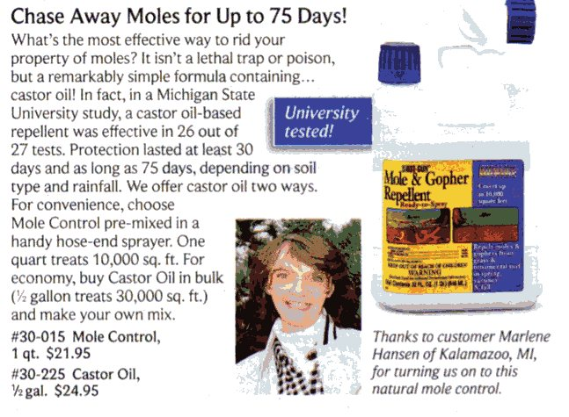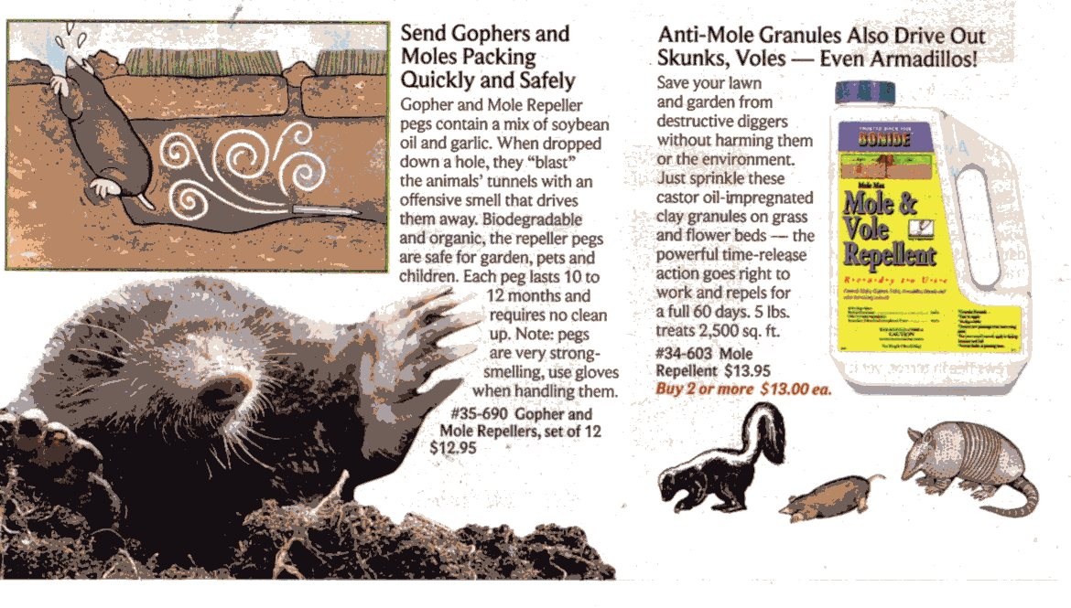

Can I trap them?
Check with your state wildlife department first and city human department. If yes, the trap Prairie Dog Pals recommends is the Baker-Williams live pocket gopher trap, shown below for residential situations. It takes a fair amount of “gopher guts” or determination to successfully trap them, but here are the basics. Prior to trapping you must select a nearby site for release. Find exit/entrance hole by brushing aside dirt of mound with hands. Look for a darker circle. This will be the plugged hole. With iron rebar, probe around for a connecting runway. The rebar probe will sink easily when it hits the air pocket of the runway. Dig down until you can see runway. Set either one trap (or two traps if the runway goes in both directions) with open end into runway at a gentle slope. Check each hour to keep animal alive and healthy. A carrot can be inserted into end of trap to keep the little guy/gal happy while you prepare for the relocation. Prepare a release tunnel with an auger or long spade by digging down about 2-3 feet. Insert pocket gopher by placing the open end of the trap into the hole. Cover the hole with excess soil. There are other options for golf greens and other similar type lands.
For details of trap design and effectiveness check out the following web site on your computer at your home or local library: http://www.jstor.org/view/0022541x/ap070141/07a00490/0
What other ideas are there for non-toxic control?
Plant plants that gophers don’t like. Install vibration devices. Plant plants only in plastic or tile pots. Encourage/allow gopher predators to frequent the area…such as construct owl boxes or creating raptor perches. Enclose yard for free range of your pet dog/cat in the back yard.

What if I still can’t stand pocket gophers?
I would suggest you get a copy of the classic movie “Caddie Shack” with comic Bill Murray on a fictitious madcap quest to catch a mythical “gopher”, watch the tube, pop open a cold one, “chill”, and have a good laugh. For more detailed information on live-trapping and non-toxic deterrents plus their ecology and other benefits, check out our website at:
http://www.prairiedogpals.org/pocketgophers/index.html, for “Every thing you wanted to know about pocket gophers but were afraid to ask?”

Do you still want to “wage war” against pocket gophers by live-trapping them? Or do you want us to try the non-toxic liquids in a controlled experiment?
Our going rate is $35 per hour for our live-capture and deterrent application services.

-Pocket Gophers-
By Paul Polechla Jr., Ph.D., Lead Wildlife Biologist
Prairie Dog Pals-Phone: (505)-296-1937. On the web at: www.prairiedogpals.org

